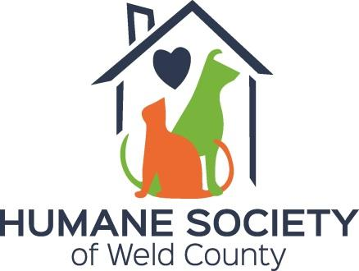
PRESS RELEASE: FOR IMMEDIATE DISTRIBUTION
The Board of Directors of the Humane Society of Weld County are excited to announce some changes in the Leadership of the organization.

Scott Gee, is joining the HSWC as Executive Director. Scott brings more than 28 years of leadership experience in the non-profit arena, most recently serving as the Executive Director for Cancer Support Community in St. Louis, MO. He has held roles in other organizations, including the Executive Director for the Brain Injury Association of Missouri, Citizens for Missouri’s Children and the Director of Development, Marketing and Public Relations for United Cerebral Palsy of Greater St. Louis.

Scott has told the board “I am tremendously excited to be joining the team. I look forward to working with the staff and the board to bring exemplary care to our animals and helping them to find the best forever families possible.”

We are also pleased to announce the addition of Brooke Bourgeois, as Director of Operations. Brooke joined the HSWC bringing with her 14 years of experience in Animal Shelter Operations. Most recently Brook held the positions of Shelter Operations Manager for the Jefferson Parish Animal Shelter in Harvey, LA.

Brooke has said “I have made animal welfare not only my career but my passion in life.”

The combination of Scott’s tremendous non-profit leadership and Brooke’s extensive shelter operations leadership will ensure that the Humane Society of Weld County can strengthen our Mission of promoting the humane treatment of animals through care, advocacy and education.

EVANS, CO. October 28, 2019

